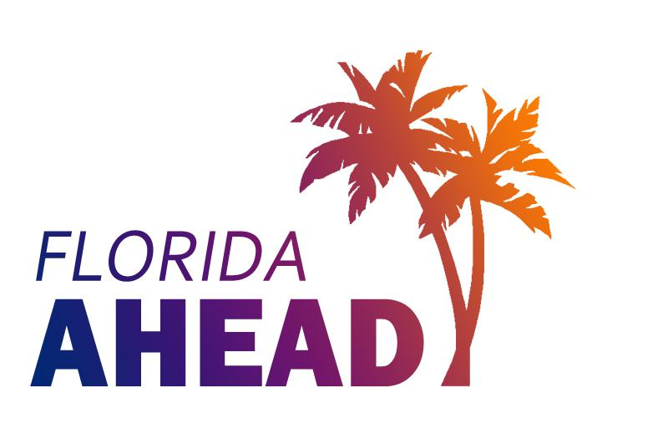
Florida Association on Higher Education and Disability (FL-AHEAD)
www.flahead.org
FL-AHEAD is a non-Profit Organization (501-C3) TAX ID: 26-3552306

Membership Application

Name: |  |  |  |  |  |  |  | Title:
Institution/Organization:
Address:
City/State: |  |  |  |  | Zip Code:
Telephone: |  |  |  |  | Fax:
TTY: |  |  |  |  | Email:
Web site:
Membership Status:
- New
- Renewal
Membership runs 7/1/20 – 6/30/21

Membership Category

Individual Professional, $ 25
Institutional Basic, $70 (includes 3 members, complete information below and on page two)
Institutional Plus, $100 (includes 5 members, complete information below and on page two)
Associate, $35
Pre-Professional (Graduate Student), $15
Student (Undergraduate), $10
Emeritus Professional, $10

As an accommodation for a disability, please provide printed Association materials in (on):
Braille
E-text
Large Print
For Institutional Basic/Plus Members – Please provide the contact information for the two other full Professional Members from your institution. Institutional Plus Members may provide information for four other members. Additional members can be purchased at $20 per member.

Name: |  |  |  |  |  |  | Title:
Address:
City/State: |  |  |  |  | Zip Code:
Telephone: |  |  |  |  | Email:

Name: |  |  |  |  |  |  | Title:
Address:
City/State: |  |  |  |  | Zip Code:
Telephone: |  |  |  |  | Email:

Name: |  |  |  |  |  |  | Title:
Address:
City/State: |  |  |  |  | Zip Code:
Telephone: |  |  |  |  | Email:

Name: |  |  |  |  |  |  | Title:
Address:
City/State: |  |  |  |  | Zip Code:
Telephone: |  |  |  |  | Fax:
TTY: |  |  |  |  | Email:

Name: |  |  |  |  |  |  | Title:
Address:
City/State: |  |  |  |  | Zip Code:
Telephone: |  |  |  |  | Email:
Payment Information:

Credit Card payments must be made online through PayPal: http://flahead.org/paypal/

 | Check enclosed payable to FL-AHEAD |  | Check #:

A service fee of $12.00 will be charged for checks returned unpaid and a Redeposit Fee of $14.00 will be charged

Purchase Order #

Purchase orders with insufficient amount will be returned.

Membership Year: July 1 – June 30 yearly; No pro-rated membership will be considered.

Please submit both pages of this form and payment made out to FL-AHEAD to:

Attention: Ashley Gorion, FL-AHEAD Treasurer
Student Accessibility Services
University of Central Florida
PO Box 160161
Orlando, FL 32816-0161

Phone: 407-823-2371
Ashley.gorion@ucf.edu

Please note: Membership on the Florida Postsecondary Disability Service Providers listserv is not automatic with FL-AHEAD membership.

To join the FPDSP listserv, please send an email to: jimmy.yawn@sfcollege.edu.

FOR OFFICE USE ONLY: Do not write below this line.

Date Application Received: ____________________ Received by: _____________

Date Application Processed:____________________ Processed by: _____________

Membership List Updated:_____________________ By:______________________

Receipt/Email Sent On:________________________ By:_____________________

Notes:

